Pad folding a Prefold or other flat nappy
The pad fold is most commonly used with prefold nappies but can also be used with terry squares or muslins. When using prefold nappies, for a smaller baby use the prefold with the panels running horizontally, for an older toddler you'll need to have the panels running vertically to make a longer nappy...
Firstly, fold one third of the nappy into the centre... |  | 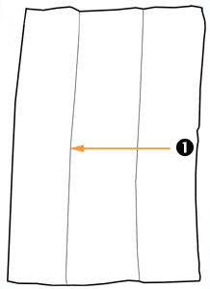
 | 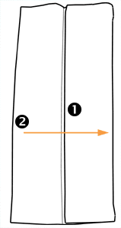 | Then do the same with the other side so you have a pad that is approximately one third of the width of the original nappy...
Simply fold the nappy up to make the pad the right length for the wrap you are using... | 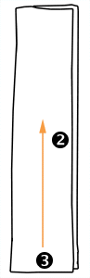
 | 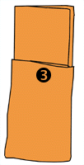 | This diagram shows the folded nappy...
Then lay the nappy in the centre of the wrap, before adding a liner if required and finally lay the baby on the nappy & wrap with the baby's waist level with the top of the wrap and pull the nappy and wrap up between the legs before fastening the wrap securely. | 