Neat Nappy Fold
Starting with the nappy laid flat, fold one corner in towards the centre. How much you fold in is dependent on how wide you need the waist of the nappy to be. The further in you fold the corner, the larger the 'waist' of the nappy will be... |  | 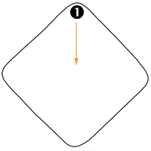
 | 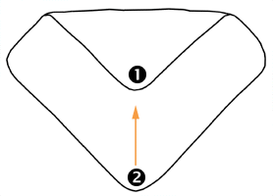 | Then fold the opposite corner up towards the centre. Again, how far to fold depends on how long you need the nappy to be and how narrow the point between the legs will end up being. You may need to spend a while experimenting with these first two folds...
Now pull corner '3' across and up so that the corner ends up in the centre of the flat edge at the top of the nappy. | 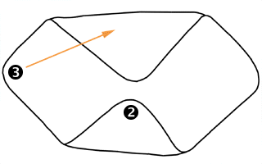
 | 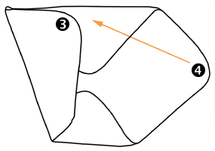 | Do the same with corner '4'
Place a liner in the centre of the nappy if required. Lay your baby on the nappy with the waist level with the top edge of the nappy. Pull the nappy ('5') up between the baby's legs and the wings ('6' & '7') around the baby's waist before fastening with a pin or nappi nippa, making sure to grip/pin fabric from all three parts of the nappy to secure it snugly. | 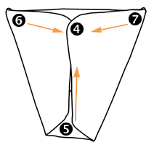
 | 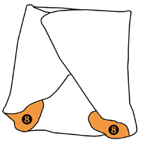 | This diagram shows the finished folded nappy (without the baby). The orange areas show the inside of the nappy and areas '8 are the leg holes.

