Kite Fold
Starting with the nappy laid flat, fold corners '1' & '2' up and to the centre of the nappy so that the flat edges meet. This determines the width of the nappy (how big round the waist it is) if the nappy is too small with the edges touching move them further apart to form a 'V' shape instead). Then fold corner '3' down over corners '1' & '2' so that the nappy forms a long triangular shape...
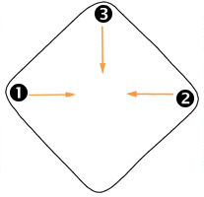 | 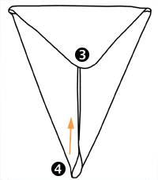 | Now fold corner '4' up towards corner '3'. How far you fold this corner is dependent on how long you want the nappy to be. You may need to experiment over the course of a few changes before you know what length gives the best fit in different wraps etc...
You should now have an upside down 'trapezoid' shape (a triangle with the top chopped off!) Place a liner in the centre of this shape if required and then lay your baby on the nappy so that the top edge is at waist level... | 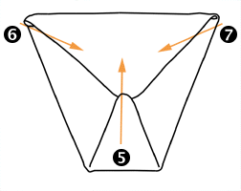
 | 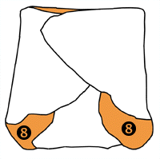 | Pull edge '5' up between the baby's legs and pull points '6' & '7' around the waist so that they cover the front of the nappy. You can now fasten with a nappi nippa or pin making sure to grip or pin fabric from all three points to secure the nappy snugly. The diagram shows the nappy folded without the baby, so positions '8' are the leg holes. Orange is used to show areas that are on the inside of the nappy.

