Bat / Chinese / Origami Fold
Starting with the nappy laid flat, fold in half...
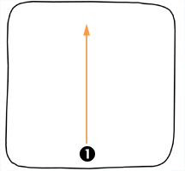 | 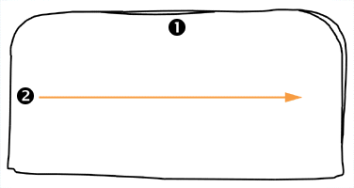
Then fold into quarters...Now the tricky bit! Pull the top layer of the quarter folded nappy (corner '3') up and out so that it lays in a triangle shape across the nappy. This may take a few attempts but you'll know when you've got it right! | 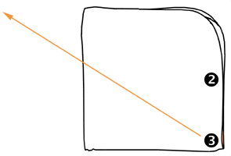
 | 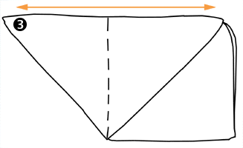 | The dotted line shows the line that the nappy follows under the triangle... Now you need to turn the whole nappy over so that the triangle is underneath and you have a square pad with a triangle corner poking out (corner '3')...
Now fold the square edge ('4') half way across the square area of the nappy... | 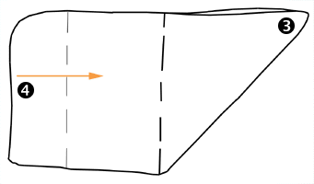
 | 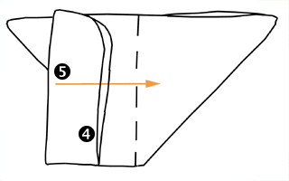 | Then fold the new edge ('5') over again, so that you have a rectangular pad through the centre of the triangle shape...
The nappy is now ready for a liner which you lay down the centre if required... Then lay your baby on the nappy with the top edge at waist level and pull the pad ('6') up between the legs and the pointed 'wings' ('7' & '8') around the waist. | 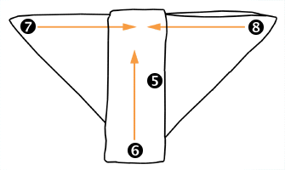
 | 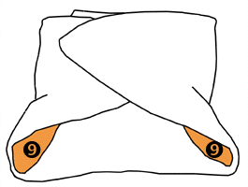 | Now fasten the nappy with a nappi nippa or a pin making sure to pin or grip fabric from each point in order to secure the nappy snugly. This diagram shows the fully folded nappy without the baby - areas '9' are the leg holes showing the inside of the nappy.

