Folding a prefold for better containment
The Angel Fold
Starting with the prefold laid out flat. For a smaller baby use the prefold with the panels running horizontally, for an older toddler you'll need to have te panels running vertically to make a longer nappy... | 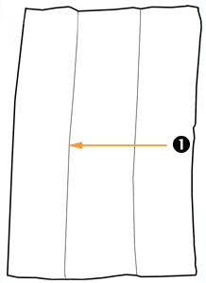
 | 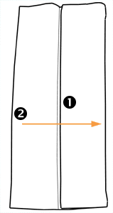 | First fold side '1' into the centre and then side '2' into the centre to form a pad that is a third of the size of the original nappy.
Then fold the bottom of the pad up to adjust the legth of the nappy to fit your baby and the wrap you are using... | 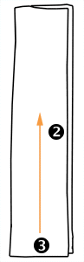
 | 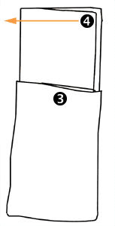 | Now pull the corner at the top of the pad ('4') out so it lays flat agin, taking care not to unfold the rest of the pad below...
Do the same with the other top corner ('5'). Now place a liner in the centr of the pad if required and lay your baby on the nappy with the top edge at wist level. | 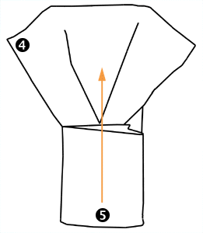
 | 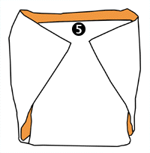 | Pull the pad ('6') up between the baby's legs and pull the 'wings' of the nappy around the waist. Depending on the size of the prefold and the size of your baby you can either fasten with a nappi nippa or pin each 'wing' to the nappy below separately. This will help provide much better conatainment than the standard pad-fold as the nappy is pulled more snugly around the baby's legs.

